https://embeddedwala.com/EmbeddedSystems/interview-questions/can-interview-questions
The Controller Area Network (CAN) protocol is a robust vehicle bus standard designed to allow microcontrollers and devices to communicate with each other without a host computer. It was developed by Bosch in the 1980s, originally for automotive applications in which Instead of connecting every device to every other device, all nodes are connected to a single shared bus, to reduce the complexity and weight of wiring harnesses.
CAN (Controller Area Network) is an asynchronous, half-duplex serial communication protocol where data is transmitted without a shared clock signal, and only one node transmits at a time over a single two-wire bus using arbitration to manage access, ensuring reliable communication between multiple nodes.
CAN is a multi-master, message-oriented protocol that enables reliable communication between nodes (electronic control units or ECUs) in real-time systems. It is widely used not just in automobiles, but also in industrial automation, medical equipment, and other embedded systems.
In CAN communication, messages are not addressed to specific devices. Instead, each message has a unique identifier, and all nodes receive all messages but decide whether to process them based on the identifier. This approach simplifies the architecture and increases flexibility.
CAN operates on a differential two-wire bus (CAN_H and CAN_L), which provides excellent noise immunity and allows for long-distance communication.
It supports two data rates: Standard CAN (up to 1 Mbps) and CAN FD (Flexible Data-rate, up to 8 Mbps or more).
The protocol supports two frame formats: Standard Frame (11-bit identifier) and Extended Frame (29-bit identifier).
The CAN protocol has built-in error detection mechanisms including cyclic redundancy checks (CRC), acknowledgement checks, and bit stuffing. If a node detects a fault, it can retry transmission or go into an error-passive state, helping ensure that faulty nodes do not disrupt the network.
CAN uses Carrier Sense Multiple Access with Collision Detection and Arbitration on Message Priority (CSMA/CD+AMP). This means all nodes listen before transmitting, and if two nodes start at the same time, the one with the higher-priority (lower-value) ID wins arbitration without data loss.
Some key advantages of CAN include high reliability, real-time performance, flexibility, error handling, and low cost for complex multi-node systems.

Bit Rate:
- Definition: Bit rate is the number of bits transmitted per second.
- Unit: bits per second (bps).
- It tells how much data is being transferred.
🧠 Example:
If 1,000 bits are transmitted in 1 second, the bit rate is 1,000 bps.

✅ Baud Rate:
- Definition: Baud rate is the number of signal changes (symbols) per second on the communication line.
- Unit: baud (symbols/second).
- One signal change (or symbol) may carry one or more bits, depending on the modulation technique.
🧠 Example:
If the baud rate is 500 baud, and each symbol carries 2 bits, then the bit rate is:
500 × 2 = 1000 bps

📊 Key Difference:
Feature | Bit Rate | Baud Rate
What it measures | Bits per second (data) | Symbols (signal changes) per second
Focus | Amount of data | Number of signal changes
Bit per Symbol | Can be >1 | Always 1 symbol per change
Equal when? | When 1 symbol = 1 bit | Then bit rate = baud rate

💬 Simple Interview Answer:
Bit rate is the number of bits transmitted per second, while baud rate is the number of signal changes or symbols sent per second. If each signal (symbol) carries one bit, bit rate equals baud rate. However, in advanced modulation techniques, each symbol may carry multiple bits, so bit rate becomes higher than baud rate. For example, if each symbol represents 2 bits, then a baud rate of 1000 results in a bit rate of 2000 bps.

Q: Describe the basic architecture of a CAN bus system.
Basic Architecture of a CAN Bus System:
Main Components of a CAN Bus System
1. CAN Nodes (or ECUs – Electronic Control Units)
Each node is a device connected to the CAN bus. It could be a sensor, control unit, or actuator. A typical CAN node includes:
- Microcontroller (MCU):
  - Brain of the node.
  - Processes incoming data and decides what to send.
- CAN Controller:
  - Follows CAN protocol rules.
  - Creates and reads CAN frames (messages).
  - Handles error detection, message filtering, and prioritization.
- CAN Transceiver:
  - Converts the digital signals from the controller into differential signals for transmission on the bus.
  - Also receives signals from the bus and converts them back to digital.

2. CAN Bus (Physical Medium)
The actual wiring used to connect all the nodes together.
- It consists of two twisted wires:
  - CAN_H (High)
  - CAN_L (Low)
- These wires carry differential voltage signals (e.g., 2V and 3V) which helps reduce the effect of electrical noise.
- All devices (nodes) are connected in parallel to this bus.

3. Termination Resistors
To ensure signal quality and avoid reflection, two resistors (120 ohms each) are connected at both ends of the CAN bus.
- They match the impedance of the bus.
- Help maintain signal integrity, especially over long distances.
Q: Explain the difference between a CAN node and a CAN message
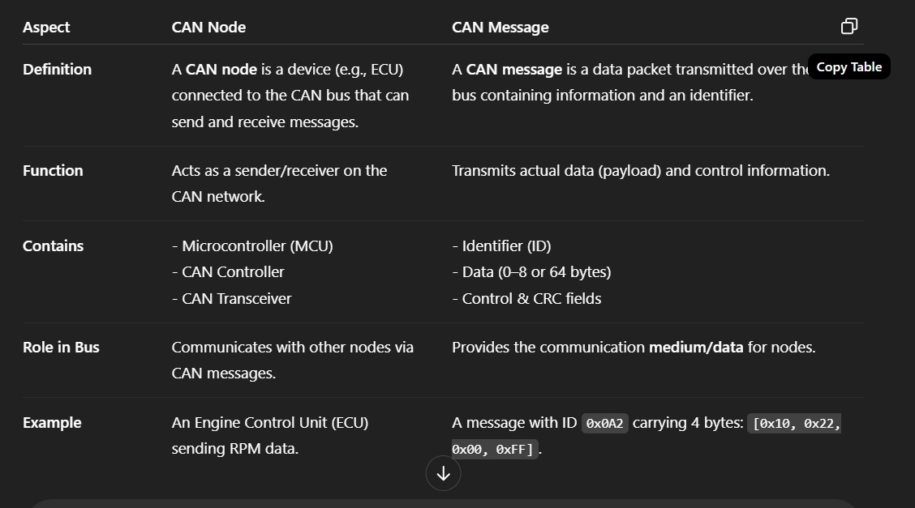
Q7: Describe the difference between standard and extended CAN identifiers.
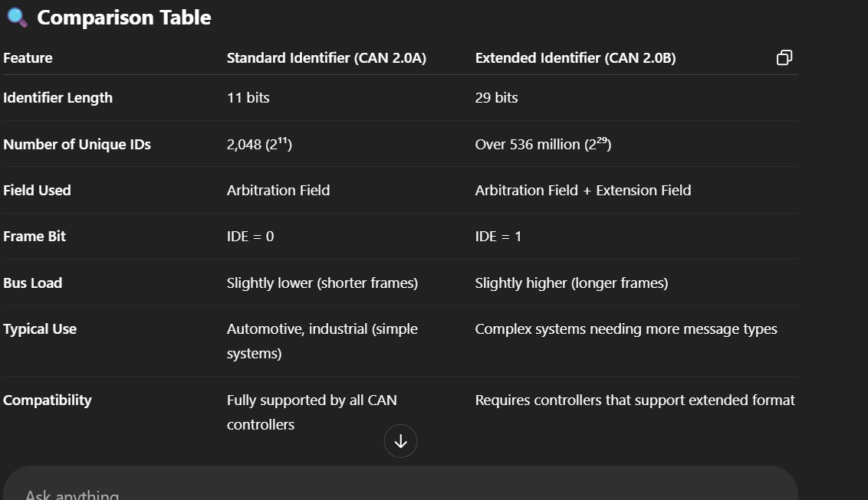
Standard Identifier defined in CAN 2.0A is 11 bits long, while the Extended Identifier in CAN 2.0B is 29 bits long.
The number of unique IDs possible with standard identifiers is 2,048 (2¹¹), whereas extended identifiers support over 536 million (2²⁹) unique IDs.
Standard frames use only the arbitration field to carry the ID, but extended frames use both the arbitration field and an extension field.
The IDE (Identifier Extension) bit distinguishes the two formats: it is set to 0 in standard format and 1 in extended format.
Standard identifiers result in slightly lower bus load due to shorter frame length, while extended identifiers have a slightly higher bus load because the frame is longer.
Standard identifiers are typically used in automotive and simple industrial systems, while extended identifiers are suited for complex systems that require more message types.
Lastly, standard format is supported by all CAN controllers, whereas extended format requires controllers that support the extended message frame format.
Q8: How does CAN bus handle message collisions?
Collision Handling in CAN Bus
CAN bus uses a special method called Non-Destructive Bitwise Arbitration to handle collisions, which ensures that no data is lost and the highest priority message is always transmitted first.

Key Points:
- Multiple nodes can attempt to transmit simultaneously:
Since CAN is a multi-master network, several nodes may start sending messages at the same time.
- Arbitration based on the Identifier:
Each node sends its message identifier bit by bit on the bus.
  - The bus uses dominant (0) and recessive (1) bits.
  - A dominant bit overrides a recessive bit on the bus.
- Bitwise arbitration process:
  - Every transmitting node compares the bit it sends with the actual bit on the bus.
  - If a node sends a recessive bit (1) but sees a dominant bit (0) on the bus, it realizes it has lost arbitration and stops transmitting immediately.
- No data loss and non-destructive:
  - The node with the lowest identifier (highest priority) keeps transmitting.
  - Other nodes back off without corrupting the message on the bus.

Summary:
- Collision is detected immediately by nodes during arbitration.
- The highest priority message wins the bus access.
- Losing nodes wait and retry transmission later.
- This method avoids data corruption and maximizes bus efficiency.
- No data corruption.
- No retransmission delay
NO.OF NODES SUPPORTED BY PROTOCOLS:
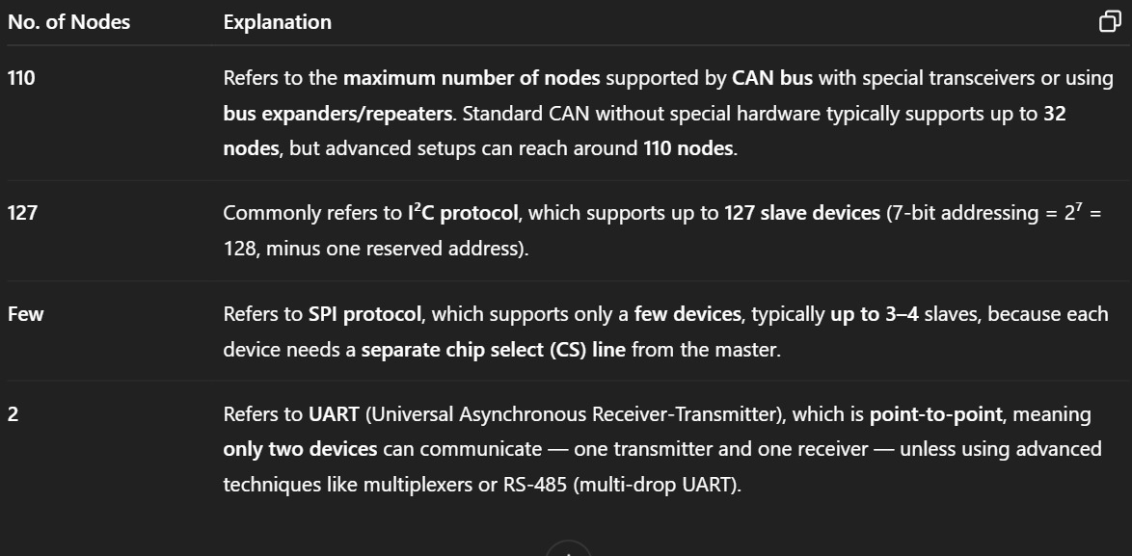

1. UART (Universal Asynchronous Receiver/Transmitter)
- Number of nodes supported:
Typically 2 nodes (point-to-point)
- How?
UART is a simple serial communication protocol designed for direct communication between two devices — one transmitter and one receiver.
- It uses separate Tx (transmit) and Rx (receive) lines.
- There's no built-in addressing or multi-node support. To connect more devices, you’d need additional hardware (like multiplexers or UART-to-bus converters).

2. I2C (Inter-Integrated Circuit)
- Number of nodes supported:
Up to 127 devices on a single bus (7-bit addressing)
- How?
I2C is a multi-master, multi-slave protocol on a two-wire bus: SDA (data) and SCL (clock).
- Each device has a unique 7-bit address (some use 10-bit addressing, but 7-bit is common).
- So, max devices = 2^7 = 128, but address 0 is reserved, so practically 127 devices.
- All devices share the bus lines, and arbitration is used if multiple masters try to communicate simultaneously.

3. SPI (Serial Peripheral Interface)
- Number of nodes supported:
Limited by the number of Chip Select (CS) lines; theoretically many slaves, practically depends on hardware wiring
- How?
SPI is a master-slave protocol using separate lines:
- SCLK (clock), MOSI (master out, slave in), MISO (master in, slave out), and CS (chip select) per slave.
- Each slave requires a dedicated CS line from the master to select it, so the max number of slaves depends on how many CS lines the master can provide.
- Common microcontrollers have a limited number of GPIOs for CS lines, so typically 4–10 devices per bus.
- There are workarounds like using decoders or multiplexers to extend this number.

4. CAN (Controller Area Network)
- Number of nodes supported:
Up to 120 nodes on a single CAN bus (practical limit), theoretically up to 2048
- How?
CAN is a multi-master broadcast bus widely used in automotive and industrial applications.
- Each node has a unique identifier (typically 11-bit standard or 29-bit extended).
- The bus is a twisted pair, with all nodes connected in parallel.
- Theoretically, the 11-bit ID allows 2^11 = 2048 unique identifiers.
- Practically, the bus is limited by electrical loading and timing constraints, typically supporting around 30–120 nodes depending on bus length and speed.

Q9: What is the maximum data transfer rate supported by CAN bus?
The standard CAN bus, or Classical CAN, supports a maximum data transfer rate of up to 1 Mbps. However, this speed is achievable only over short distances — typically up to 40 meters.
As the length of the CAN bus increases, the data rate must be reduced to maintain signal integrity and reliability. For example:
- At 250 kbps, the distance can go up to 250 meters.
- At 125 kbps, it can reach up to 500 meters.
With CAN FD (Flexible Data-Rate), the speed can be increased up to 8 Mbps, but only during the data phase and over very short distances — typically less than 10 to 20 meters.
So in summary:
- Classical CAN: Up to 1 Mbps @ 40 meters
- CAN FD: Up to 8 Mbps @ short distances (≤20 meters)
- For longer distances, data rates are reduced accordingly.

Q10: How does CAN bus handle error detection and error handling?

The CAN bus has a very robust error detection and handling mechanism, which is one of its key strengths, especially in safety-critical systems like automotive and industrial control.
CAN uses five methods to detect errors:
- Bit Monitoring:
  - Each node monitors the bits it sends.
  - If a node sends a dominant bit but reads a recessive one (or vice versa), a bit error is detected.
- Bit Stuffing:
  - After five consecutive bits of the same polarity, a complementary bit is inserted (stuffed).
  - If the receiving node does not detect a correct stuffed bit, it flags a bit stuffing error.
- Frame Check:
  - Checks whether the format of the CAN frame is correct (e.g., CRC delimiter, ACK slot).
  - Detects format or frame errors.
- Cyclic Redundancy Check (CRC):
  - Each message includes a CRC field.
  - The receiver calculates the CRC and compares it with the received value. A mismatch signals a CRC error.
- Acknowledgment Check:
  - The sender checks if at least one receiver has acknowledged the frame.
  - If no ACK is received, it's considered an acknowledgment error.
Error Handling:
- When a node detects an error, it immediately transmits an Error Frame to notify all other nodes.
- CAN uses a fault confinement mechanism: nodes monitor their own behavior using two counters:
  - Transmit Error Counter (TEC)
  - Receive Error Counter (REC)
- Based on these, a node can enter one of three states:
  - Error Active – Normal operation
  - Error Passive – Can still send/receive but cannot signal errors actively
  - Bus Off – Node is disconnected from the bus if too many errors occur
This self-monitoring ensures that faulty nodes do not disturb the network and helps maintain high reliability.

Why Termination Resistors Are Important:
- The CAN bus is a differential transmission line.
- Typical CAN bus cable has a characteristic impedance of 120 ohms.
- Each end of the bus must have a 120-ohm resistor to match the impedance
- If there's no termination, signals bounce back from the ends of the cable, which can causing interference and data corruption.
- Termination resistors absorb these reflections, preventing them from bouncing back.
- Prevent Signal Reflections
- This ensures minimal signal distortion.
- Stabilize the Bus.
- Helps maintain a defined recessive state (logic 1) when no nodes are transmitting.

Types of Frames in CAN Protocol
The CAN (Controller Area Network) protocol defines four main types of frames, each serving a specific purpose in the communication process:
1. Data Frame
Most commonly used frame
Carries actual data from one node to others
Contains identifier, data length, data field, CRC, etc.
📌 Used for: Sending sensor readings, control commands, etc.
2. Remote Frame
Requests data from another node
Contains the identifier of the data it wants, but no data field
📌 Used for: Polling another node to send a specific message
3. Error Frame
Sent by a node when it detects an error
Interrupts current transmission to maintain data integrity
Consists of:
Error flag (sent by the node detecting the error)
Error delimiter (used to separate frames)
📌 Used for: Error detection and recovery in real-time systems
4. Overload Frame
Sent by a node to delay the next data frame
Contains Overload flags
Used when a node needs extra time to process data
📌 Used for: Preventing buffer overflows in receivers

Bit stuffing is a method used in CAN communication to maintain synchronization between the sender and receiver.
In CAN protocol, data is sent as a continuous stream of bits without a separate clock signal.
So to keep everything in sync, the receiver relies on changes in bit values (like from 0 to 1 or 1 to 0).
If there are too many same bits in a row, like five 1s or five 0s, there won’t be any change, and the receiver might lose sync.
To solve this, CAN uses bit stuffing.
It means that whenever five identical bits appear in a row, the sender automatically inserts a bit of the opposite value.
For example, if the sender wants to send five 1s: 11111, it adds a 0 after it, making it 111110.
This added bit is called a stuffed bit.
The receiver knows this rule, so when it sees five same bits, it checks the next one, and if it’s opposite, it removes it.
If the actual data contains a sequence like 111110, the CAN protocol handles it by bit stuffing another 0, so the receiver sees 1111100, removes the first stuffed 0, and correctly keeps the real 0 — so no data is lost or misinterpreted.
This way, both sender and receiver stay synchronized and understand the original data correctly.
Bit stuffing also helps avoid confusion with special patterns in CAN, like the end of a frame.
Without it, a long string of same bits could look like a control signal and cause errors.
So overall, bit stuffing improves reliability and helps in error-free communication over the CAN bus.

How does CAN bus handle communication between nodes with different bit rates?
In standard CAN bus communication, all nodes must operate at the same bit rate (i.e., the same baud rate).
CAN does not support communication between nodes with different bit rates on the same bus. Here's why and how this is handled:
🔹 Why Same Bit Rate is Required:
- CAN is a synchronous protocol: All nodes sample each bit at the same time.
- If nodes run at different speeds (bit rates), they will misinterpret the data or cause errors (like ACK errors or stuffing errors).
- The arbitration mechanism (used for deciding which node transmits when) also depends on synchronized timing.
In CAN bus, all nodes must use the same bit rate to communicate correctly because the protocol depends on synchronized timing. If one node uses a different bit rate, it will cause errors, and communication will fail.
CAN doesn’t support mixed bit rates on the same bus. If communication between nodes at different speeds is required, either CAN FD can be used or multiple CAN buses with a bridge node can be implemented.
So to maintain reliability, all nodes in a standard CAN network are configured to the same bit rate.
What is Message Filtering in CAN Bus?
Message filtering is the process by which a CAN node selects which messages to receive based on the message ID.
In a CAN network, all nodes receive all messages, but not every node is interested in every message.
To avoid unnecessary processing, filters are used to accept only relevant messages.
A CAN (Controller Area Network) frame, or message, is a packet of data transmitted over the CAN bus. It follows a standardized format, with fields for arbitration, control, data, and error handling. There are two main CAN frame formats: standard and extended, primarily differentiated by the length of the arbitration ID.

Standard CAN Frame Format (CAN 2.0A)
- Start of Frame (SOF): A single dominant bit (0) indicating the start of a frame.
- Arbitration ID: 11-bit identifier used for arbitration and prioritizing messages.
- Remote Transmission Request (RTR): A bit that indicates if the frame is a data frame (0) or a remote request (1).
- Identifier Extension (IDE): Indicates if the frame is a standard or extended format.
- Data Length Code (DLC): A 4-bit field specifying the number of data bytes in the frame.
- Data Bytes: Up to 8 bytes of data.
- Cyclic Redundancy Check (CRC): A 15-bit field for error detection.
- Acknowledgement (ACK): A bit used by receivers to acknowledge frame reception.
- End of Frame (EOF): A sequence of recessive bits signaling the end of the frame.

ACK Mechanism: Step-by-Step
- Sender Sends Message:
  - The transmitting node sends a data frame over the CAN bus.
- ACK Slot (1-bit field):
  - After the CRC field, there is a 1-bit ACK slot in the CAN frame.
- Receivers Monitor Frame:
  - All receiver nodes check the message.
  - If the message has no errors (CRC is valid), the receiver node:
Pulls the ACK slot to dominant (0).
- Sender Checks ACK Slot:
  - The transmitter monitors the ACK slot:
    - If it sees dominant (0) → At least one node received the message correctly ✅
    - If it sees recessive (1) → No node acknowledged → Transmit again ❌
- ACK Delimiter (1 bit):
  - Follows the ACK slot.
  - This is always recessive (1) and marks the end of the ACK field.

1. Introduction to CAN Protocol
- Developed by Bosch in 1986 for automotive applications.
- A multi-master, message-oriented protocol that allows microcontrollers and devices to communicate without a host computer.

✅ 2. Features of CAN
- Multi-master capability
- Message priority and arbitration
- High reliability with error detection
- Speeds up to 1 Mbps (Classic CAN), up to 5 Mbps (CAN FD)
- Supports real-time and fault-tolerant communication

✅ 3. Types of CAN
Type | Description
CAN 2.0A | 11-bit Identifier (Standard CAN)
CAN 2.0B | 29-bit Identifier (Extended CAN)
CAN FD | Flexible Data rate (up to 64 bytes per message, higher speed)

✅ 4. CAN Frame Format
🧩 Types of Frames:
- Data Frame – Transmits data (0–8 bytes or 0–64 in CAN FD)
- Remote Frame – Requests data from a node
- Error Frame – Sent when an error is detected
- Overload Frame – Delays the next frame to allow processing
🧩 Standard Data Frame Format (11-bit ID):
CopyEdit
| SOF | ID | RTR | IDE | r0 | DLC | Data | CRC | ACK | EOF | IFS |
Fields:
- SOF: Start of Frame
- Identifier (ID): Message priority (lower value = higher priority)
- RTR: Remote Transmission Request
- IDE: Identifier Extension (0 = standard, 1 = extended)
- DLC: Data Length Code (0 to 8)
- CRC: Cyclic Redundancy Check
- ACK: Acknowledgement from receiving nodes
- EOF: End of Frame
- IFS: Inter-frame Space

✅ 5. Bit Stuffing
- After 5 consecutive identical bits, a complementary bit is inserted to maintain synchronization.
- Receiver removes the stuffed bit during decoding.

✅ 6. Arbitration Mechanism
- Non-destructive bitwise arbitration: Dominant bit (0) overrides recessive (1)
- Used to decide which node can transmit when multiple nodes send at the same time
- Lower ID = higher priority

✅ 7. Error Detection & Handling
Types of Error:
- Bit Error
- Stuff Error
- CRC Error
- Form Error
- Acknowledgment Error
Mechanisms:
- Error Counter: Transmit Error Counter (TEC) & Receive Error Counter (REC)
- Error States:
  - Error Active
  - Error Passive
  - Bus-Off

✅ 8. Physical Layer
- Differential signaling: CAN_H and CAN_L
- Idle State: Both lines at ~2.5V
- Dominant (0): CAN_H > CAN_L
- Recessive (1): CAN_H ≈ CAN_L
Bus Topology:
- Multi-drop with two 120Ω termination resistors at both ends

✅ 9. CAN Transceiver
- Converts digital data from MCU to differential signals and vice versa.
- Examples: MCP2551, TJA1050

✅ 10. Baud Rate and Timing Segments
- Nominal Bit Time = Sync Segment + Propagation Segment + Phase Segment 1 + Phase Segment 2
- Sample Point is typically 87.5% of bit time

✅ 11. CAN Node States
- Transmitting
- Receiving
- Idle
- Error Handling / Recovery

✅ 12. CAN FD (Flexible Data Rate)
- Higher data payload (up to 64 bytes)
- Higher speed during data phase
- Dual-bit rate support

✅ 13. Software Implementation
- CAN controllers: Internal (in MCU like LPC2129, STM32), or external (MCP2515)
- Libraries: Keil (for LPC), STM32 HAL CAN driver, Arduino CAN libraries
- Configuration steps:
  - Set baud rate and timing
  - Configure ID (standard/extended)
  - Enable filters if needed
  - Enable interrupts
  - Send/receive messages

✅ 14. Applications of CAN
- Automotive ECUs: Engine, Transmission, ABS, Airbags
- Industrial automation
- Medical equipment
- Aerospace

✅ 15. Comparison with Other Protocols
Feature | CAN | I2C | SPI | UART
Speed | Up to 1 Mbps (CAN FD: 5 Mbps) | 100k/400k | 10+ Mbps | 1 Mbps
Distance | >40m | <5m | <1m | <15m
No. of Nodes | 110 | 127 | Few | 2
Arbitration | Yes | No | No | No
Reliability | Very High | Moderate | Low | Low

✅ 16. Common Interview Questions
- What is the purpose of bit stuffing in CAN?
- How does CAN handle collisions?
- Difference between standard and extended CAN?
- What happens during an acknowledgment error?
- How do CAN nodes recover from Bus-Off state?
- Explain the CAN physical layer signaling.
- How is priority determined in CAN messages?

